Social Sport Ladder
Administrator’s Guide
An administrator can not create a new ladder, this can only be done by the super user. Once a ladder is created they have to configure the ladder.
When they log in the new ladder will show up with the title in “strike through” font. This indicates that no players can use this ladder yet.
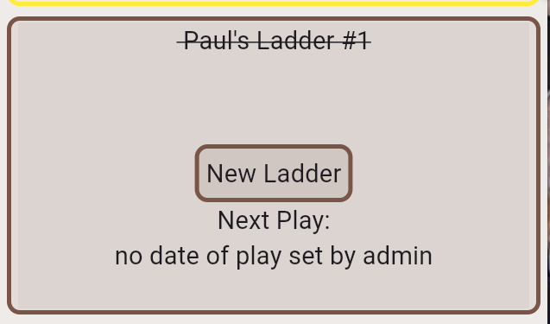
Note that the name of the ladder will be provided to you by the super user, but you can change the Display name.
Click anywhere in the box:
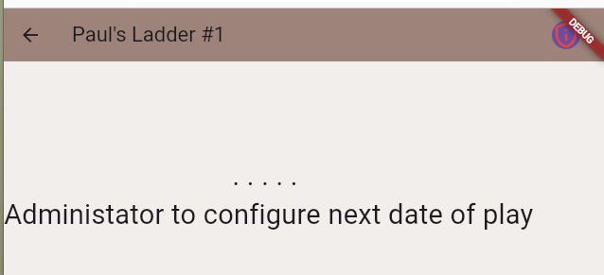
You now must enable Admin functions by clicking in the icon on the top right:


and clicking on :Enable Admin Functions:
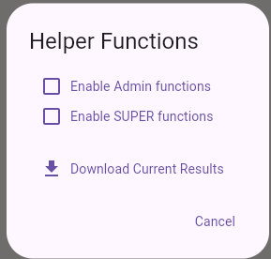

A new icon will now be visible on the top near the right, click on that to configure your ladder:


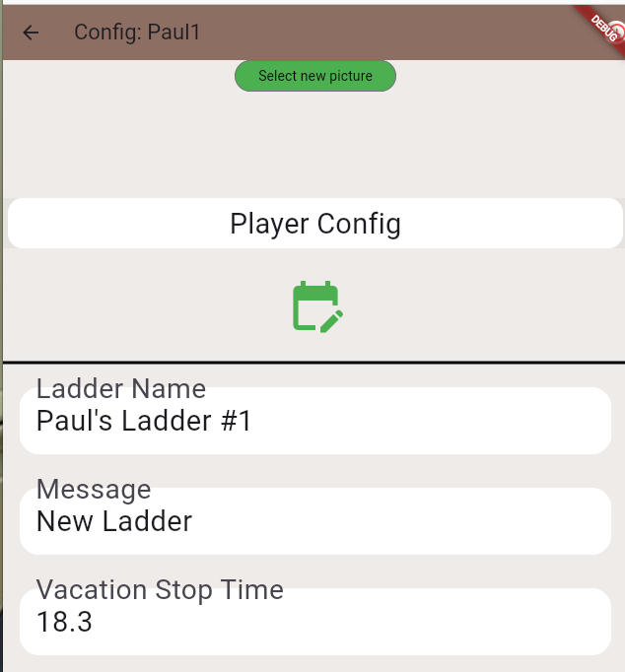

Select new Picture


Use this to upload a picture that will be displayed in multiple places to identify this ladder. It is best if the image file (e.g. jpg) is in wide format with a height of no more than 100 pixels.
Example:
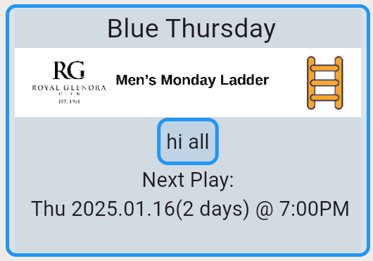

Image
The next space to show the image

Player Config Text Button


This will bring you to a new page that allows you to add new players and set their names and whether they are a helper or not.

Calendar Icon Button


This will bring you to a new page that allows you to set the days of play and what time they will play on each week.

Ladder Name – text field
This is the display name of the Ladder. This must be more than 5 characters long and no more than 20 characters long. You can set this to what ever you would like, there are no restrictions that it must be unique. Note that the ladder identifier that was supplied by the super user, is only visible to administrators, all players will use this name to identify the ladder.

Message – text field
This is the message that appears inside the box on the Ladder Selection Page inside the interior box. In the Blue Thursday example above it says “hi all”. You can use this text to fully describe the ladder, but you can insert any text you want, as long as it is less than 100 characters. Note that extra spaces will be removed. (you can not insert double spaces, or spaces at the beginning or end)

Vacation Stop Time – text field number
This is the hour of the day at which time players will no longer be able to indicate that they will be away. This affects the Calendar page. The format of the number is the hour in 24 hour clock format (18.00 means 6pm). After the decimal point the minutes can only be .00, .15, .30 and .45.
NOTE: if you want to make it the day previous to the play date at 8:15am you can set it to 108.15, 2 days previous would be 208.15
This is normally used when it is useful to the administrators to know ahead of time how many people are coming. If you want to disable this function make it the same or after the start time of the ladder.

Check in Start Hours Ahead – text field number
This has to be a number between 0 and 23 and it also allows minutes of .00, .15, .30 and .45
NOTE: a value of zero means players can not check in until the actual start time of the ladder while a value of 3 means that they can check in 3 hours ahead but not more. For example for a start time of 6:00 and a value of 3, they can check in from 3:00 to 6:00.
Generally you want this number to be fairly small to prevent people from checking in and then leaving because they found something else to do. A player that checks in but is not there to play is very annoying to the other players on their court.

Latitude of Courts – text field number
This has to be a floating point number between -90.00000 and 90.00000. This corresponds to the latitude of your courts and is used to make sure that players can only mark themselves present if they are actually at (or near) the courts. This can be disabled by entering a large number in “Meters From Court to Check In”
You can get the latitude and longitude of any map location on Google Maps by right clicking on the map. It will show up the the numbers on the top of the popup menu.
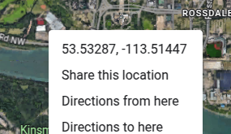

Longitude of Courts– text field number
This has to be a floating point number between -180.00000 and 180.00000. This corresponds to the longitude of your courts and is used to make sure that players can only mark themselves present if they are actually at (or near) the courts. This can be disabled by entering a zero in “Meters From Court to Check In”

Meters From Court to Check In – text field number
This has to be a floating point number between 0 and 5000.0. The units are meters which are approximately the same as yards. Note that a value of 0 makes it disabled a value of 1 makes it almost impossible for your players to check in. A typical value might be 350 to include the parking lot.

Random Seed – text field
When the number of players that are present is not divisible by 4, then some courts will be assigned 5 players meaning someone has to sit out. This number is the random seed used to determine which courts will be courts of 5. This number is randomly generated after scores are entered and finalized. Normally you do not have to set this number, but if you want to force the courts of 5 you can do it here.
The entered number must be between 0 and 2000. Usually the random seed is between 0 and 1000, but for some ladders the number being greater than 1000 is used to affect how the courts are assigned, so that you can alternate between 2 methods.

LaddersThatCanView – text field not editable
This is a list of which other ladders are allowed to view this ladder. This is set only by the super user. It can be used for closely affiliated ladders when there are no privacy concerns. Players from these other ladders will be able to see the ladder, but of course can not play.

HigherLadder – text field
This must exactly match the id of another ladder. NOTE: this is the id not the Display Name.
In cases where you wish to combine multiple ladders because you have run out of courts, you can join the ladders by marking one as the HigherLadder and the other as the LowerLadder. This enables a special administrator function to move players from one ladder to the other.
NOTE: these joined ladders should probably also be indicated in “LaddersThatCanView”

LowerLadder – text field
This must exactly match the id of another ladder. NOTE: this is the id not the Display Name.
In cases where you wish to combine multiple ladders because you have run out of courts, you can join the ladders by marking one as the HigherLadder and the other as the LowerLadder. This enables a special administrator function to move players from one ladder to the other.
NOTE: these joined ladders should probably also be indicated in “LaddersThatCanView”

Display Color – menu
This affects the displayed color on the LadderSelection page, and the Player list. There are only a small number of choices. This is used to make it more clear which ladder is being selected when a player belongs to more than one ladder.

Admins – text field separated by commas
The super user would have put your email address in as an admin. If you want you can enter other people to be admins, maybe as backups when you are away on holidays.
If the new admin does not already have an account registered to login, you will have to also add them as a Player so that their email address is registered, then you can delete that player.
Note that the super user, is also an admin whether or not they are listed here.

PriorityOfCourts – text field separated by vertical pipe | characters
This allows you to create the names for each of the courts. Often these are just numbers, but they can be anything. If you define 7 courts like “Show|9|10|Gary|2|3|4” but you only need 3 courts then only the first 3 names will be used. Unused courts will be dropped starting at the end of this list.

Disabled – menu
This has 2 choices: True and False. This should be set to false after you have completed configuration of the Ladder and you want to have your configured players have access to this Ladder.
It is important that this be set to false if you want your players to be able to use this ladder.

SportDescriptor – text field – not editable
This is set by the super user and is set to options separated by a vertical pipe character |. This selects options in the software, the actual meaning of each of the fields may change.
The first field is what general sport is being used, while the second and subsequent fields are some special options.

Player Config
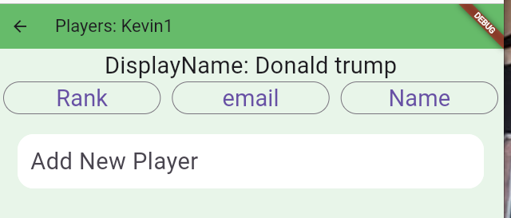
This page is used to add Players or to edit players.

Add New Player – text field
Enter an email address for the new player. This can not be the same as any email for other players in the ladder. Note that 2 players can not share the same email address. The email address is used to uniquely identify the players, but the email address is only shown to administrators.
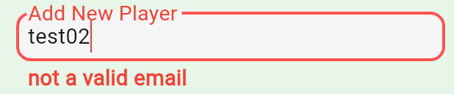
If a proper email address is entered then press the Icon on the right to save it:
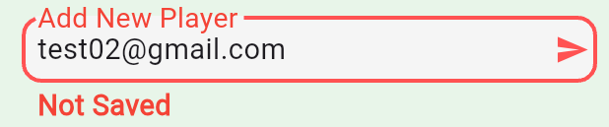
If you try to enter the same email address twice you will get an error, and the save icon will not appear:
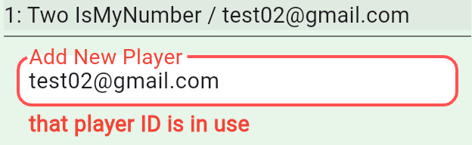
SPECIAL NOTE: If this is a brand new player and it was necessary to create a login then Google will cause you to be logged in as that user. If you leave this screen you should log out and then log in as your self. If you don’t leave this screen then you can continue with the same permissions as yourself. There are multiple warning messages that this is happening.

Select Player
If you click on any player you will get this displayed
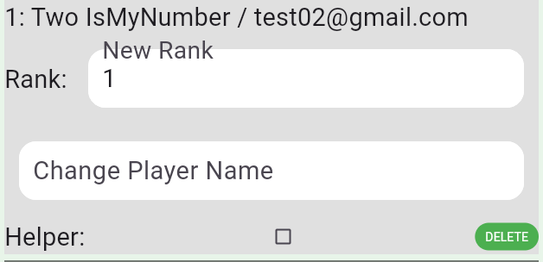

Change Player Name – text field
Type in the name that you want displayed on the player list. Note that the email addresses will not be displayed. You can not have 2 players with the same name in the same ladder. Press the save icon on the right to save.
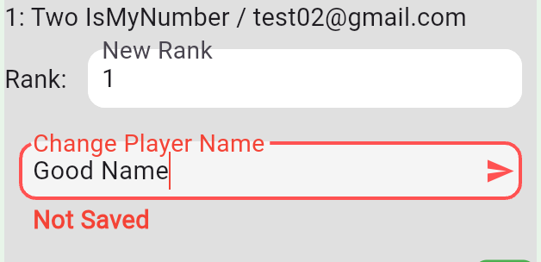

New Rank – text field for number
Valid numbers must be greater than 0 and less than the current number of players. Press the save icon when ready, and wait for the list to re-order.

Helper – checkbox
Use this to give the user permission to be a helper. It is very important that every ladder have at least 3 helpers unless you, as an administrator is planning to be there all of the time.

DELETE – text button
Press this to delete the user, and wait for the display to update.

Sort Buttons at the Top
If you have a ladder with lots of players you might find it convenient to sort the list in different ways:
By Rank (the default)
By their email addresses
By their Display Names
Just click the button the the list will redraw.

Results CSV File
The results CSV files are created whenever the ladder is finalized. They can be found in the calendar view for the admin accessed via the Ladder Configuration screen. Click on the blue square for the date that you want the results from:
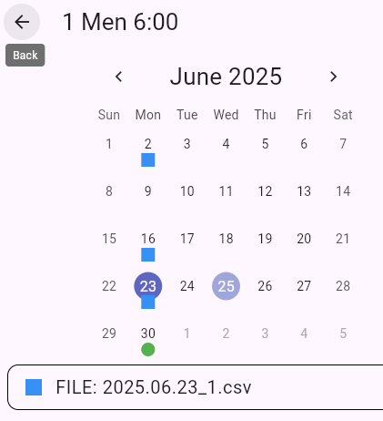

Then when you click on the button at the bottom it will download the csv file. This is usually done on a laptop or desktop computer, as the file is usually loaded directly into Excel, or OpenOffice Calc. There is usually a “import” window that comes up, and you can usually just press “OK”. (The separator option is “Separated by Comma”).
The following are what is in each column:
- Rank – The rank of the player at the start of this week. This file is sorted by this column so it should start at 1 and go up to the number of the players in the ladder e.g. 30
- NewR – The new rank of the player after the scores are finalized. These should be unique (no duplicates) and be the same range as the Rank column, but be in a different order.
- Present – this is the text “true” if the player checked their name off that they were ready to play. Otherwise is is blank (empty)
- Unassigned – this is rarely used but it indicates if there was a bad number of players like 6,7 or 11 and one or two of the players was not allowed to play.
- Away – this shows as the text “true” if the player properly indicated themselves as going to be away for this week.
- Player Name – this is the Name of the player.
- Score – this is the total score. This is the sum of columns Scr1, Scr2, Scr3, Scr4, Scr5
- Pos – this is their position on the court so it is a number from 1 to 5 (or for some sports 6)
- Court# - this is which court they were assigned to. This is not the name of the court. The top court is 1.
- CourtName – this is the name of the court as defined in PriorityOfCourts in the Ladder configuration.
- Aw+- - this is how much this player moved due to being away or due to others being away
- tot+- - this is the total change in rank for the player. This is the difference between the columns Rank and NewR. Note that a negative number is moving down the ladder even though the rank is increasing.
- TimePresent – this is the date and time that the player marked themselves present.
- Scr1, Scr2, Scr3, Scr4, Scr5 – these are the entered scores for this player for each set. Numbers that are not used, for example only 3 scores are entered for a court of 4, are left blank.
- WeeksAwayWithoutNotice – this is the number of weeks that this player has not marked themselves as present (did not play) and also did not mark themselves as away. These stats are reset by the admin, usually at the start of each session.
- WeeksAway – this is the number of weeks that this player has not marked themselves as present. This number will always be greater than or equal to WeeksAwayWithoutNotice. These stats are reset by the admin, usually at the start of each session.
- WeeksPlayed – this is the number of weeks since the admin last reset the stats. This will always be the same for all players, with the exception of new players that are added in the middle of a session.
Some example interesting stats:
The Greatest mover: this would be the player with the largest number in “tot+-” column, usually ignoring all negative numbers.
The Dominator: usually the player with the largest “Score”, but does not apply unless at least 18. In case of tie, the margin of victory over the second place person on the court is usually used to break the tie. Plus often a player is eliminated from contention if they have not been playing regularly (have been away a lot recently). This last bit requires looking at previous results.
Court Winner: this is of the players on the same Court, the one with the highest Score. This requires manually checking this out.

